https://dotnet.microsoft.com/en-us/download/visual-studio-sdks?cid=msbuild-developerpacks

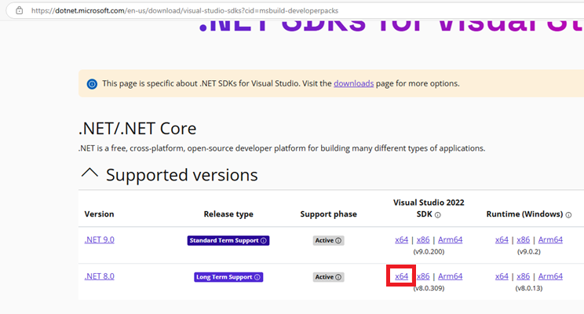

https://visualstudio.microsoft.com/downloads/

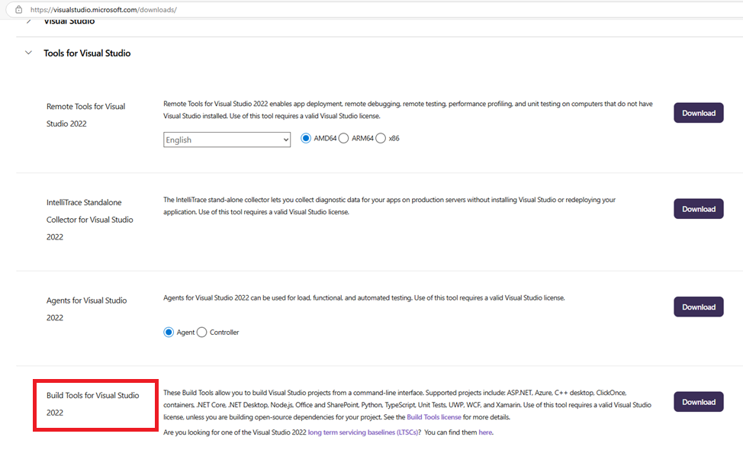

https://dotnet.microsoft.com/en-us/download/dotnet/8.0

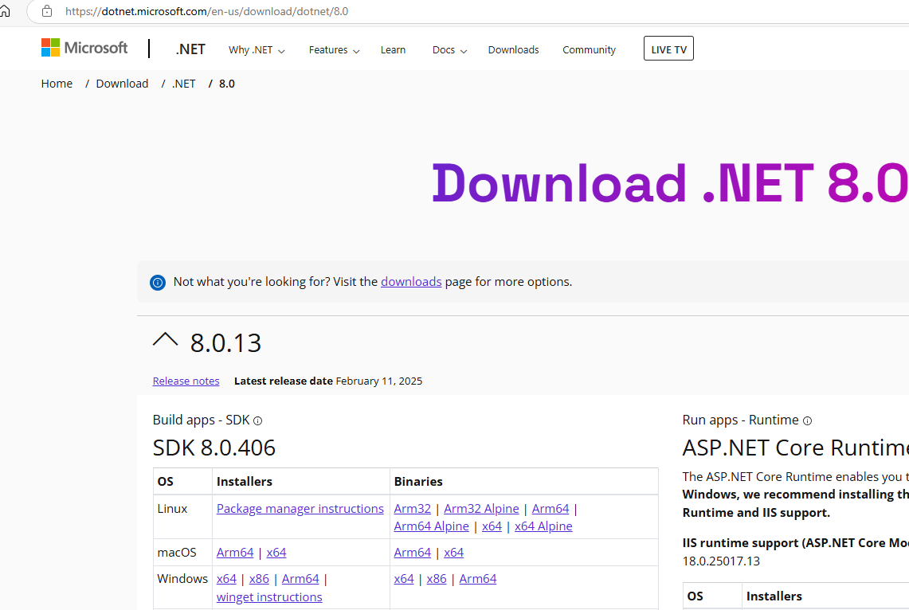

https://learn.microsoft.com/en-us/cli/azure/install-azure-cli-windows?pivots=msi

